### Common Test Roles

**# Source**: **Chatgpt (GPT-5-Standard) at [8/12/2025]**

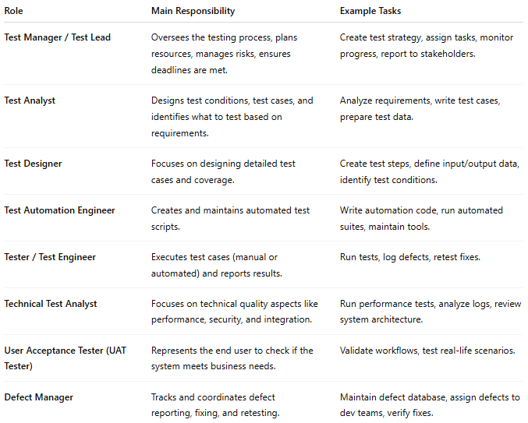

| **Role** | **Main Responsibility** | **Example Tasks** |
| --- | --- | --- |
| **Test Manager / Test Lead** | Oversees the testing process, plans resources, manages risks, ensures deadlines are met. | Create test strategy, assign tasks, monitor progress, report to stakeholders. |
| **Test Analyst** | Designs test conditions, test cases, and identifies what to test based on requirements. | Analyze requirements, write test cases, prepare test data. |
| **Test Designer** | Focuses on designing detailed test cases and coverage. | Create test steps, define input/output data, identify test conditions. |
| **Test Automation Engineer** | Creates and maintains automated test scripts. | Write automation code, run automated suites, maintain tools. |
| **Tester / Test Engineer** | Executes test cases (manual or automated) and reports results. | Run tests, log defects, retest fixes. |
| **Technical Test Analyst** | Focuses on technical quality aspects like performance, security, and integration. | Run performance tests, analyze logs, review system architecture. |
| **User Acceptance Tester (UAT Tester)** | Represents the end user to check if the system meets business needs. | Validate workflows, test real-life scenarios. |
| **Defect Manager** | Tracks and coordinates defect reporting, fixing, and retesting. | Maintain defect database, assign defects to dev teams, verify fixes. |